Specifications for the Dashboard for Raw Material Inventory module

# UI Mock-up

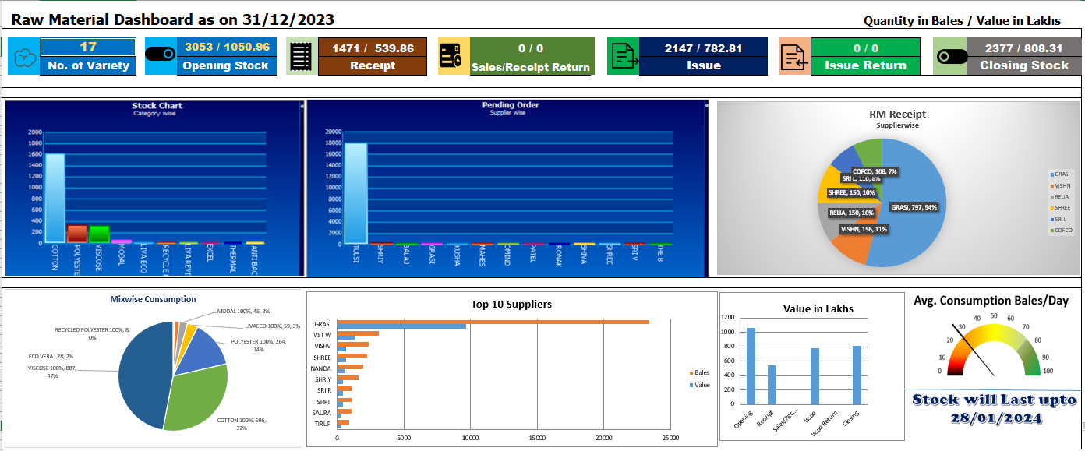

The colours, fonts and graphics used in the mock-up design are for illustration purpose only and you need not use them as such. Please use vivid and professional colours as appropriate for the content.

# Info Cards on Top

The following table provides necessary information for rendering the info cards.

|  |  |  |
| --- | --- | --- |
| **Card** | **Description** | **Comments** |
| No. of Variety | Range: 1-9999 | We shall provide the drill-down as the list in a modal popup in the next iteration. |
| Opening Stock | The first part is number of bales and the second part is total value. The range for the bales is 0-999999 and the range for the value is 0-9999.99 and two decimal places are required. | We shall provide the drill-down as the hierarchical grid in a modal popup in the next iteration. The first level will be category and the second level will be variety. |
| Receipt | The first part is number of bales and the second part is total value in lakhs. The range for the bales is 0-999999 and the range for the value is 0-9999.99 and two decimal places are required. | We shall provide the drill-down as the hierarchical grid in a modal popup in the next iteration. The first level will be category and the second level will be variety. |
| Sales/Receipt Returns | The first part is number of bales and the second part is total value in lakhs. The range for the bales is 0-999999 and the range for the weight is 0-9999.99 and two decimal places are required. | We shall provide the drill-down as the hierarchical grid in a modal popup in the next iteration. The first level will be category and the second level will be variety. |
| Issue | The first part is number of bales and the second part is total value in lakhs. The range for the bales is 0-999999 and the range for the value is 0-9999.99 and two decimal places are required. | We shall provide the drill-down as the hierarchical grid in a modal popup in the next iteration. The first level will be category and the second level will be variety. |
| Issue Return | The first part is number of bales and the second part is total value in lakhs. The range for the bales is 0-999999 and the range for the value is 0-9999.99 and two decimal places are required. | We shall provide the drill-down as the hierarchical grid in a modal popup in the next iteration. The first level will be category and the second level will be variety. |
| Closing Stock | The first part is number of bales and the second part is total value in lakhs. The range for the bales is 0-999999 and the range for the value is 0-9999.99 and two decimal places are required. | We shall provide the drill-down as the hierarchical grid in a modal popup in the next iteration. The first level will be category and the second level will be variety. |

**Web API URL/Method**:

# Bar Chart – Stock

|  |  |  |
| --- | --- | --- |
| **Axis** | **Description** | **Comments** |
| X | Category | 10 Characters Max |
| Y | Bales | Range 0-999999 |

**Web API URL/Method**:

# Bar Chart – Pending Order

|  |  |  |
| --- | --- | --- |
| **Axis** | **Description** | **Comments** |
| X | Supplier | 8 Characters Max |
| Y | Bales | Range 0-999999 |

**Web API URL/Method**:

# RM Receipt - Pie Chart

|  |  |  |
| --- | --- | --- |
| **Info** | **Description** | **Comments** |
| Slice | Supplier | 8 Characters Max |
| Slice by Value | Percentage | 99.99 |
| Slice Label | Supplier + No. of Bales + Percentage |  |

**Web API URL/Method**:

# Mixwise Consumption – Pie Chart

|  |  |  |
| --- | --- | --- |
| **Info** | **Description** | **Comments** |
| Slice | Mix | 20 Characters Max |
| Slice by Value | Percentage | 99.99 |
| Slice Label | Mix Name + No. of Bales + Percentage |  |

**Web API URL/Method**:

# Top 10 Suppliers – Horizontal Bar Chart

|  |  |  |
| --- | --- | --- |
| **Axis** | **Description** | **Comments** |
| X | Bales | Range 0-999999 |
| X | Values | Range 0-9999.99 |
| Y | Supplier | 8 Characters Max |

**Web API URL/Method**:

# Value in Lakhs – Bar Chart

|  |  |  |
| --- | --- | --- |
| **Axis** | **Description** | **Comments** |
| X | Cards | 10 Characters Max (Colours should match with info cards) |
| Y | Value | Range 0-99999 |

**Web API URL/Method**:

# Avg. Consumption Bales/Day - Speedometer

|  |  |  |
| --- | --- | --- |
| **Value** | **Description** | **Comments** |
| Minimum | 0 |  |
| Maximum | 9999 | We shall display the average value here. |

**Web API URL/Method**:

Stock will last up to - Text & Date

|  |  |  |
| --- | --- | --- |
| **Value** | **Description** | **Comments** |
| Text & Date | DD/MM/YYYY format |  |